MACHINE LEARNING · WEEK 3 · LABORATORY
Lab 3: Logistic Regression, Softmax and Naive Bayes from Scratch
Sigmoid and log loss · gradient descent for classification · confusion matrices and thresholds · softmax regression · Gaussian and multinomial Naive Bayes

Item | Details
Programme | BSc in Artificial Intelligence — Central Asian University, Fall Semester 2026–2027
Syllabus | Week 3 lab: logistic regression and maximum likelihood, multiclass classification, Naive Bayes
Duration | ≈ 3.5 hours in the lab; finish at home if needed
Files | ML_Week3_Lab3_Classification_Starter.ipynb (you work in this notebook)
Data | Palmer penguins (seaborn-data on GitHub) · Wisconsin breast cancer (built into scikit-learn) · SMS Spam Collection (5,572 messages)
Submission | Lab03_<Surname>_<Name>.ipynb, run top to bottom, by the deadline announced in class

1. Learning outcomes
After this lab you will be able to:
- implement the sigmoid in a numerically stable way, the log loss, and the gradient of logistic regression — and verify the gradient numerically;
- train logistic regression with gradient descent from scratch and reproduce scikit-learn's result;
- use predicted probabilities: build a confusion matrix, compute precision and recall, choose a decision threshold from costs, and read coefficients as odds ratios;
- implement softmax regression for three classes with the cross-entropy loss;
- implement Gaussian and multinomial Naive Bayes from scratch, explain Laplace smoothing, and build a working SMS spam filter.

2. Before you start
- Open Google Colab (colab.research.google.com) → File → Upload notebook → choose the starter notebook. Or open it in Jupyter on your own computer (Python 3.10+, NumPy, pandas, matplotlib, scikit-learn).
- The notebook downloads the penguin and SMS data from GitHub — you need internet access. The breast-cancer data come with scikit-learn.
- Read the cell “How to use this notebook”. Every code cell has a text cell above it with: What this cell does, Your task, Hint, Expected result.
- Run the cells in order. When a CHECK cell prints ✓, move on. If it stops with an AssertionError, read its message — it tells you what is wrong.
Label in the notebook | Meaning
# TODO | Code you must complete — replace None, pass or the placeholder line.
# CHECK … — do not edit | Automatic test: prints ✓ when your work is correct. 13 CHECK cells in total.
Your answer (…) | A text cell for a 2–5 sentence explanation in your own words.
Expected result | What you should see. Differences in the last digit are fine.

3. Overview and marks
Part | Topic | Time | Marks
A | Sigmoid, stable sigmoid, log loss, gradient check | 30 min | 15
B | Logistic regression from scratch (penguins) | 45 min | 20
C | Breast cancer: confusion matrix, threshold, odds ratios | 35 min | 20
D | Softmax regression for three species | 40 min | 20
E | Gaussian Naive Bayes and an SMS spam filter | 50 min | 20
F | Reflection questions; notebook quality | 10 min | 5
 | Total | ≈ 3.5 h | 100

Part A — The sigmoid, the log loss and the gradient
WHAT YOU NEED TO KNOW
Logistic regression turns a linear score into a probability with the sigmoid, measures quality with the log loss, and is trained with the gradient of that loss. All three come from Lecture 3, Parts 02–03.

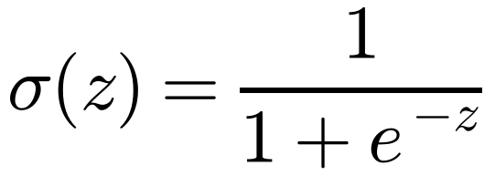
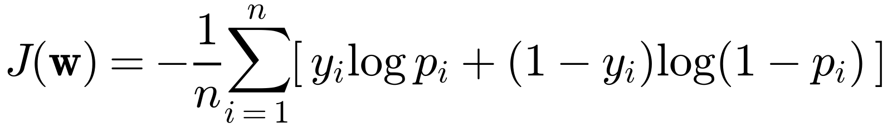
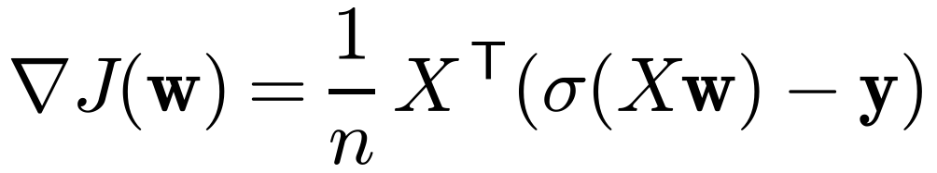

Tasks
Task | What you do | Expected result
A1 | Write sigmoid(z) with np.exp. | σ(−2), σ(0), σ(2) = 0.1192, 0.5, 0.8808
A2 | Write stable_sigmoid(z): clip z to [−500, 500] first. It replaces sigmoid. | σ(−1000), σ(0), σ(1000) = 0, 0.5, 1 with no warning
A3 | Write log_loss_np(y, p). | 0.272 on the five examples; matches scikit-learn
A4 | Write gradient(w, A, y); compare with a numerical gradient (central differences). | difference < 10⁻⁸
Questions: A3 — which example costs most and what is the loss of always predicting 0.5? A4 — what is the gradient contribution of an example that is predicted perfectly, and of one that is badly wrong?

Part B — Logistic regression from scratch on the penguins
WHAT YOU NEED TO KNOW
Task: Adelie (y = 0) or Chinstrap (y = 1) from bill length and depth. 219 penguins, split 75 % / 25 % with random_state = 0. Features are standardised with the training mean and standard deviation, and a column of ones is added for the bias.
A small L2 penalty λ = 1/n (not on the bias) makes your model identical to scikit-learn's default LogisticRegression(C = 1).

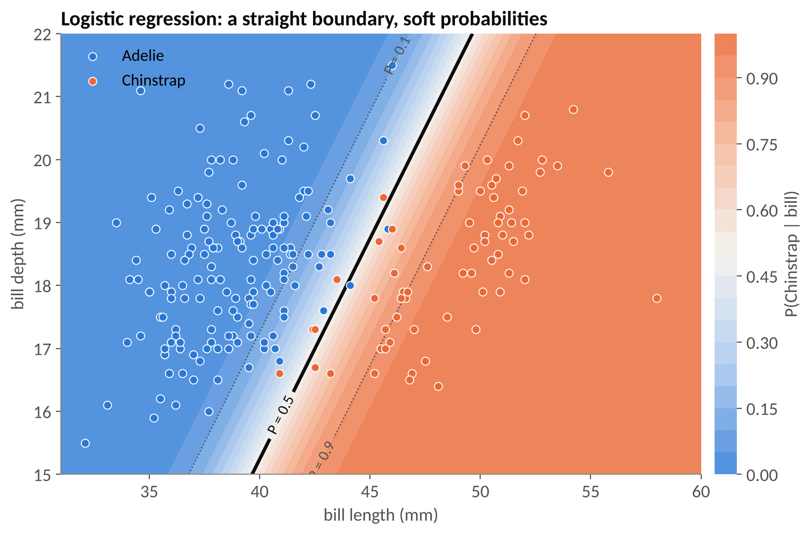
The model you will build: a straight decision boundary with soft probabilities (all 219 birds shown).
Task | What you do | Expected result
B0 | Run the data preparation. | A_train (164, 3), A_test (55, 3); 31.1 % Chinstrap
B1 | Complete the gradient-descent loop of fit_logistic (η = 0.5, 2000 steps, λ = 1/n). | w ≈ (−1.848, 3.842, −1.177); loss 0.0865; matches scikit-learn
B2 | Write predict(w, A, t) and compute accuracies. | training 0.970, test 0.964
B3 | Complete the boundary formula s₂ = −(w₀ + w₁s₁)/w₂ and plot. | loss curve from 0.693; straight boundary
B4 | Run three learning rates (300 steps). | 0.1782, 0.0893, 0.0865
B5 | Run the separable Adelie-vs-Gentoo experiment. | largest |w| 2.9, 8.7, 24.4, 43.3 as C grows
Questions: B4 — why does logistic regression tolerate much larger learning rates than linear regression? B5 — why do the weights grow without limit on separable data, and which setting prevents it?

Part C — Breast cancer: probabilities, thresholds and odds ratios
WHAT YOU NEED TO KNOW
569 biopsies, 30 measurements of cell nuclei; we code malignant = 1. You may use a scikit-learn pipeline for the model, but you write the evaluation yourself.
Confusion matrix: rows = truth, columns = prediction: [[TN, FP], [FN, TP]]. Recall = TP/(TP + FN); precision = TP/(TP + FP). Cost-based threshold: t* = C_FP/(C_FP + C_FN). Odds ratio of a standardised feature: e^w per standard deviation.

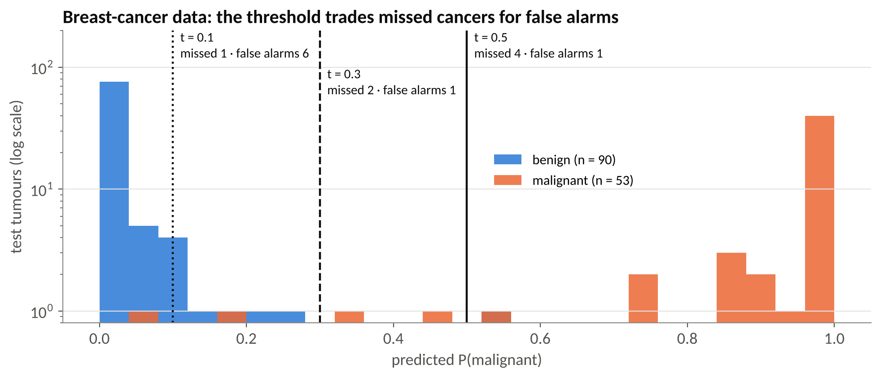
Predicted probabilities on the test set and three thresholds.
Task | What you do | Expected result
C0 | Load and split (random_state = 42). | training (426, 30), test (143, 30); 53 malignant in test
C1 | Pipeline StandardScaler → LogisticRegression; probabilities p_bc. | test accuracy 0.965
C2 | Write confusion_2x2 from scratch. | [[89, 1], [4, 49]]
C3 | Write recall_precision. | recall 0.925, precision 0.980
C4 | Loop over t = 0.5, 0.3, 0.1. | missed 4 / 2 / 1; false alarms 1 / 1 / 6
C5 | Top-5 coefficients and their odds ratios. | worst texture ×3.92, radius error ×3.55, worst symmetry ×2.82, …
Questions: C4 — which threshold if a missed cancer is 20 times worse than a false alarm, and why choose it on validation data? C5 — why is a negative coefficient for “compactness error” not evidence that compact nuclei are protective?

Part D — Softmax regression for three species
WHAT YOU NEED TO KNOW
Weights W have one column per class. P = softmax(AW); loss = cross-entropy; gradient (1/n) Aᵀ(P − Y) + λW (no penalty on the bias row). Labels are one-hot rows of the identity matrix: np.eye(3)[y].
Stable softmax: subtract each row's maximum before exponentiating — use keepdims=True.

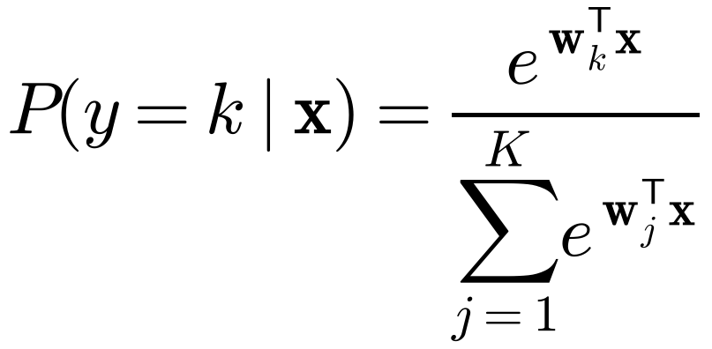
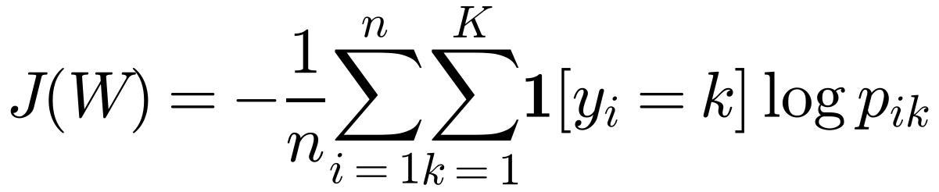
Task | What you do | Expected result
D0 | Build the one-hot matrix Y_train. | A3_train (256, 3), Y_train (256, 3), counts 113 / 51 / 92
D1 | Write a stable softmax(Z). | [0.659, 0.2424, 0.0986]; no overflow for scores ≈ 1000
D2 | Write cross_entropy(Y, P). | log 3 = 1.0986 for uniform predictions
D3 | Complete fit_softmax (η = 0.5, 3000 steps, λ = 1/n). | loss 0.1207; probabilities within 0.01 of scikit-learn
D4 | Accuracy, confusion matrix, new penguin (45, 17). | accuracy 0.954; (0.162, 0.549, 0.289) → Chinstrap
D5 | Plot the decision regions. | three regions with straight boundaries
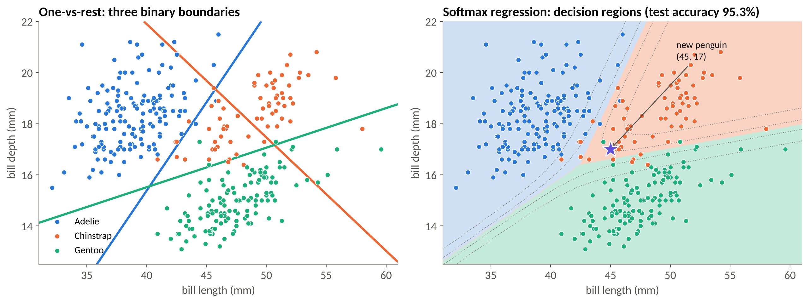
One-vs-rest boundaries (left) and the softmax regions you will reproduce (right).
Question D: why do all test errors involve Chinstrap, and why is its recall the lowest?

Part E — Naive Bayes: Gaussian and a spam filter from scratch
WHAT YOU NEED TO KNOW
Naive Bayes is generative: estimate P(y) and P(x_j | y) for each class, assume the features are independent given the class, and predict the class with the largest log prior plus sum of log-likelihoods. Training is counting and averaging — no gradient descent.
Gaussian NB: one mean and variance per class and feature. Multinomial NB for text: word probabilities from counts, with Laplace smoothing α.

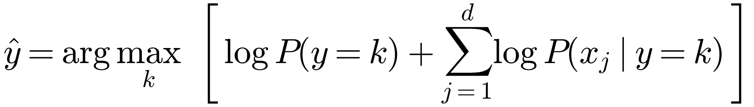
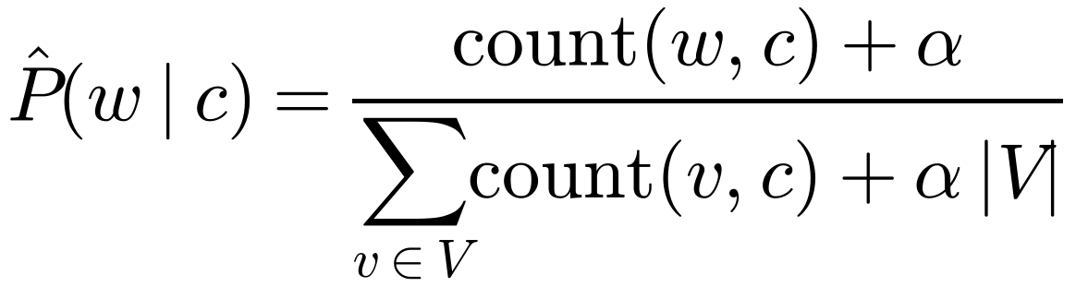
Task | What you do | Expected result
E1 | Gaussian NB from scratch on the penguins (raw mm). | priors 0.441 / 0.199 / 0.359; test accuracy 0.93; same predictions as scikit-learn
E2 | Load the SMS data; bag of words with CountVectorizer (fit on training only). | C_train (4179, 7387); spam fraction 0.134
E3 | Write mnb_fit (log prior, smoothed log word probabilities). | log prior (−0.1439, −2.0099); equal to MultinomialNB
E4 | Score in log space with one matrix product; predict. | accuracy 0.9864; [[1204, 2], [17, 170]]
E5 | Zero-count demo: “Did you claim it? Call me when you get home”, α = 0 vs 1; then five α values. | P(spam) = 1.0 (α = 0) vs 0.0001 (α = 1)
E6 | Ten most spam-indicative words. | claim, prize, 150p, tone, guaranteed, 500, cs, 18, 1000, awarded
E7 | Compare with logistic regression and the baseline. | 0.9785 and 0.8658
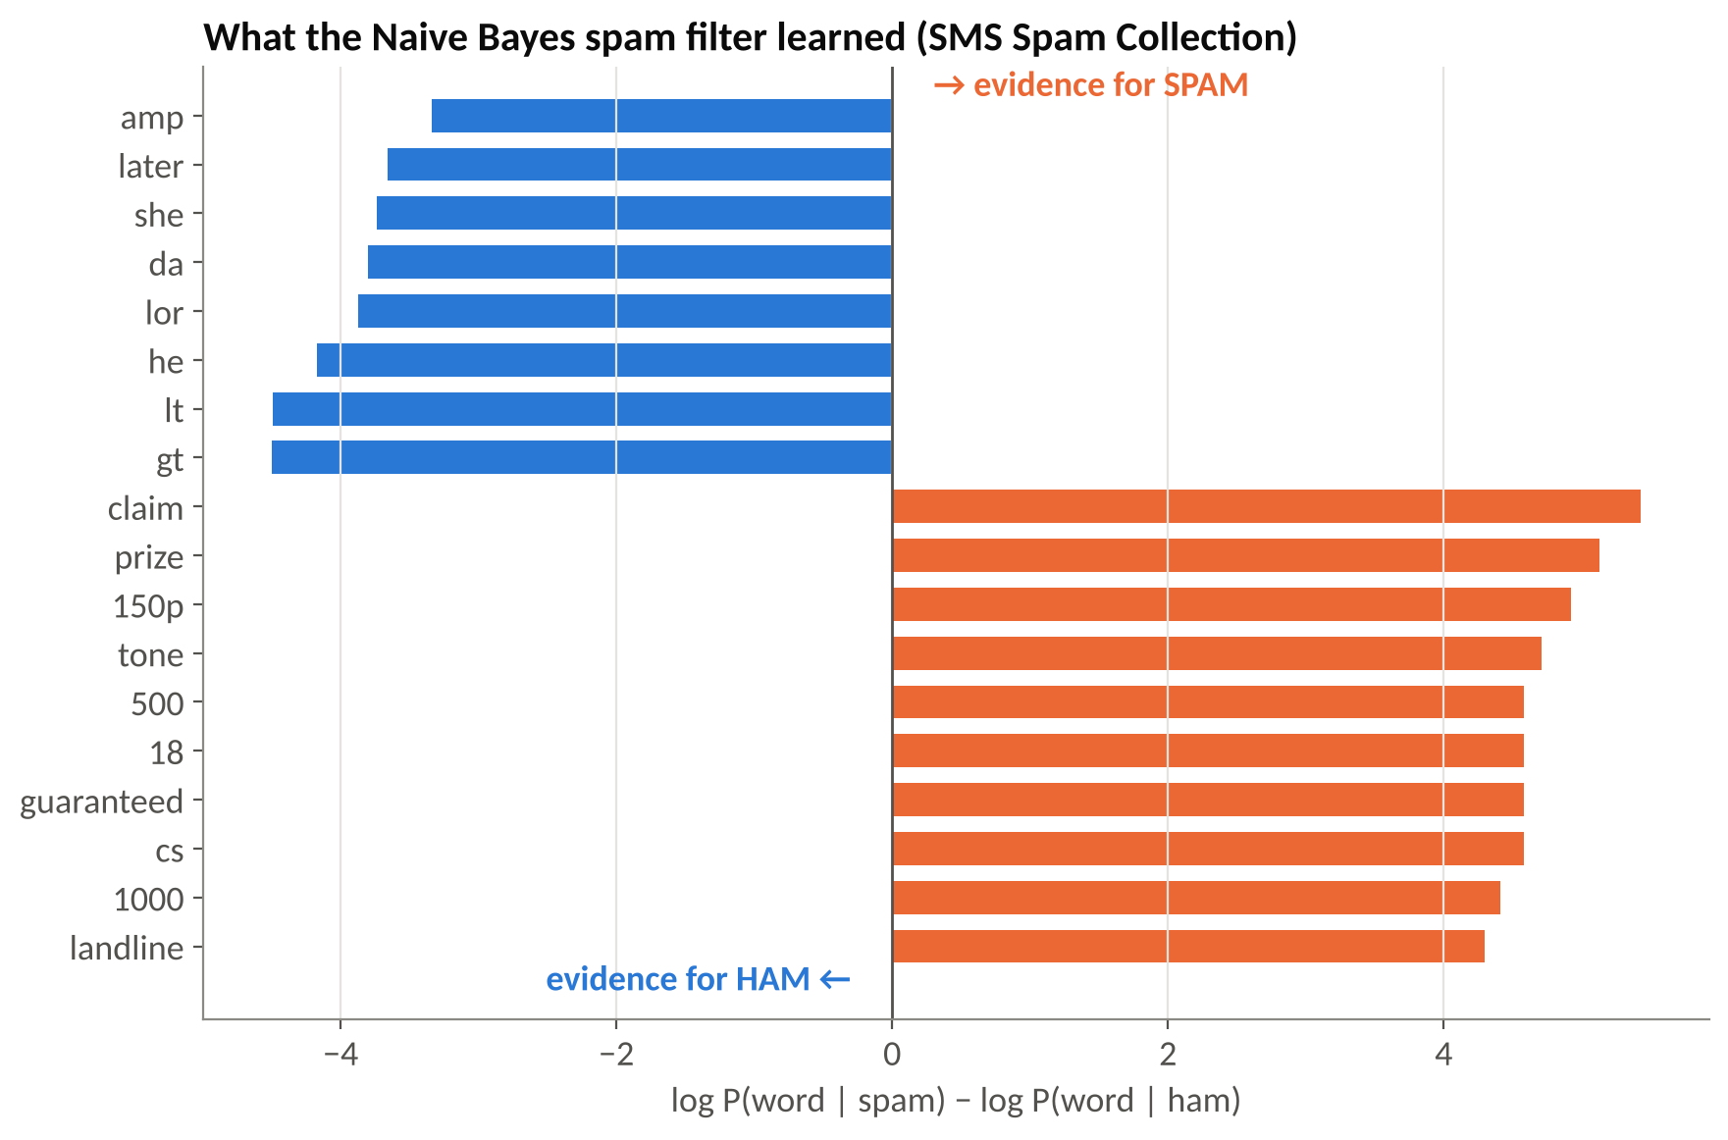
What a Naive Bayes spam filter learns. Note the artefacts lt, gt and amp (HTML fragments).
Questions: E1 — is conditional independence plausible for bill length and depth? E5 — why is the unsmoothed model 100 % sure, and why may we not choose α on the test set? E7 — which mistakes matter more for a phone company, and which model would you deploy?

Part F — Reflection
- Where does the common gradient form (1/n) Aᵀ(prediction − truth) come from? Which Week 2 loss had the same form?
- Why did logistic regression need gradient descent while Naive Bayes was trained by counting? Use the words discriminative and generative.
- Give an example from the lab where the 0.5 threshold is a poor choice, and how you would choose a better one.
- Which part was hardest for you, and what helped?

4. Troubleshooting — the ten most common problems
Symptom | Likely cause and fix
TypeError: unsupported operand … NoneType | A function still returns None. Complete the TODO in the cell named in the error, then rerun the cells below it.
RuntimeWarning: overflow encountered in exp | Expected in A2 for the old sigmoid. Later it means you are not using stable_sigmoid — rerun A2.
ValueError: matmul: … mismatch | Shape error. Print A.shape, w.shape. For one example in D4, use x_new[None, :] to make it a 1 × 3 matrix.
CHECK B1 fails, weights ≈ 0 | The update line still reads w = w. Use w = w - eta * g.
CHECK B1 fails, weights close but not equal | Penalty applied to the bias, or wrong λ. Use lam * np.r_[0, w[1:]] and lam = 1 / n_train.
Softmax gives nan | You did not subtract the row maximum, or used keepdims=False.
Softmax rows don't sum to 1 | Divided by the sum of the whole matrix instead of each row: use axis=1, keepdims=True.
E3 CHECK fails slightly | Smoothing denominator must be counts.sum(axis=1, keepdims=True) + alpha * C.shape[1] (α times the vocabulary size).
Download fails (penguins or SMS) | No internet access. Ask the assistant for the CSV/TSV file, upload it to Colab and replace the URL by the file name.
Results differ in the 3rd decimal | Different library versions — fine. Large differences mean a bug: compare with the expected result in the cell's text.

5. Submission checklist
- Restart and run all — no errors.
- All 13 CHECK cells print ✓ (A1–A4, B1, C1, C2, D1–D3, E1, E3, E4).
- Plots B3 and D5 visible.
- All written answers completed (A3, A4, B4, B5, C4, C5, D, E1, E5, E7, F1–F4).
- File named Lab03_<Surname>_<Name>.ipynb and uploaded.

6. Marking rubric
Part | Points | Full marks when
A | 15 | A1–A4 CHECKs pass; answers mention log 2 and the zero contribution of perfect predictions
B | 20 | B1 CHECK passes; accuracies and boundary correct; B4/B5 answers explain bounded curvature and infinite MLE weights
C | 20 | C1, C2 CHECKs pass; recall/precision and threshold table correct; odds ratios; C4/C5 answers (t ≈ 0.05, validation data, conditional coefficients)
D | 20 | D1–D3 CHECKs pass; accuracy, confusion matrix and new-penguin probabilities; answer D
E | 20 | E1, E3, E4 CHECKs pass; zero-count demo and spam words; answers E1, E5, E7
F | 5 | Thoughtful reflections; clean notebook that runs top to bottom

7. Optional extensions (no marks, for the curious)
- Add bigrams to the spam filter: CountVectorizer(ngram_range=(1, 2)). Does accuracy improve? What happens to the vocabulary size?
- Choose α and the decision threshold of the spam filter with 5-fold cross-validation on the training set (GridSearchCV), then evaluate once on the test set.
- Replace gradient descent in Part B with Newton's method: w ← w − H⁻¹∇J, with H = (1/n) Aᵀ diag(p(1 − p)) A. How many steps does it need?
- Fit Gaussian Naive Bayes with all four penguin measurements and compare it with softmax regression on the same features.

References
- Lecture 3 slides and speaker script (Week 3).
- James et al. (2023), An Introduction to Statistical Learning with Python, Ch. 4.
- Jurafsky & Martin, Speech and Language Processing (3rd ed. draft): Naive Bayes and logistic regression chapters.
- Almeida, Gómez Hidalgo & Yamakami (2011), SMS Spam Collection. · Street, Wolberg & Mangasarian (1993), breast-cancer data. · Gorman, Williams & Fraser (2014), Palmer penguins.

